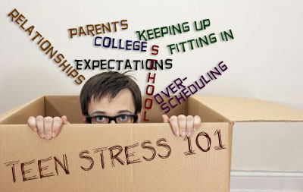

Talk with a partner or with your table group:

- Do you agree that these are the main stressors (things that cause stress) in a teen's life?
- What should not be on the list?
- What would you add to the list?
- What do YOU think is the best way to handle stress?

